Open Milestones - As of 4/6/18

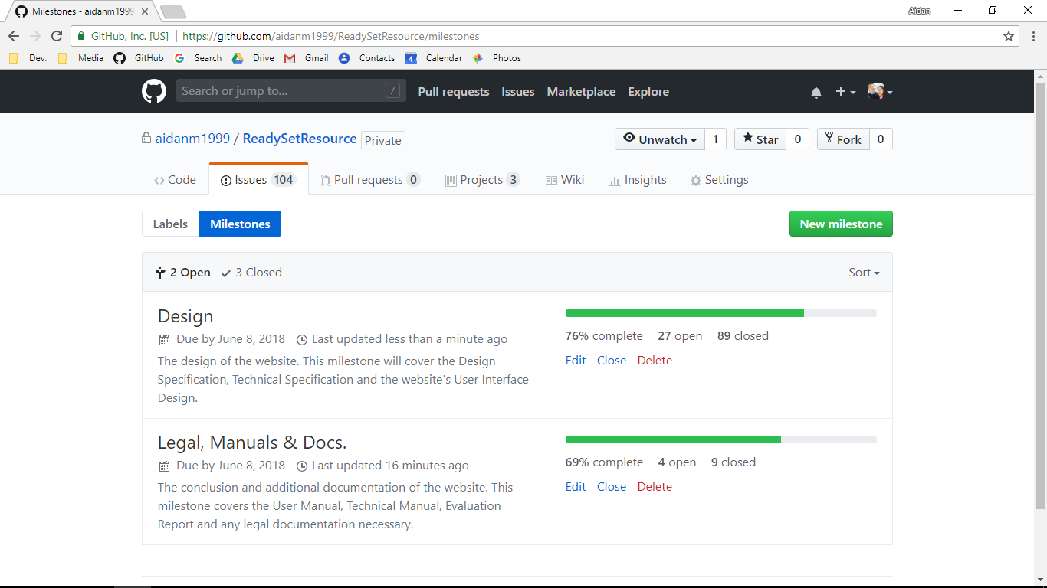

Closed Milestones - As of 4/6/18

